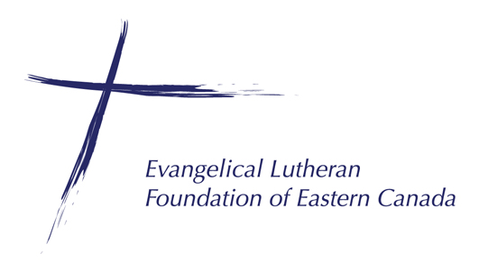

Planning Giving Workshop Request

Congregation Information
Congregation Name:
Congregation Address:
Primary Contact:
Contact Phone/Email:

Workshop Details which you would like to see covered:
 |  | Intro Planned Gifts |  | Impact of Gifts |  | Endowments |  | Gifts of Securities
 |  | Intro ELFEC |  | Types of Gifts |  | Tax Planning |  | Other _________________

Dates for Workshop: 1st: |  |  | 2nd:

Reason/Background for Workshop:
Please send complete form to Jeff @ jpym@elfec.ca and we will be in touch to follow up on request.

