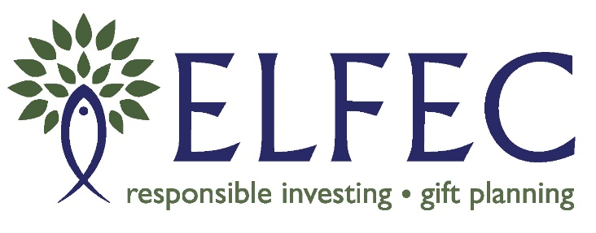
Partner Grant Program
Application Form

Organization Name
Contact Person’s Name
Organization’s Address, City, Postal Code
Email Address

Project Description
Proposal Name:
Provide a description of your proposal:
Identify the objectives, expected social or environmental results and who will benefit from your proposal:

Amount of Grant Requested (max $2,000) | $
Total Anticipated Cost of Proposal | $

What will the requested funds (grant) be spent on?
Expenditure Description | Amount
 | $
Total Expenditures | $

Are you expecting to receive funding for this proposal from other sources? | YES |  | NO
If yes, indicate the organization and the amount of funding
Name: | $

For additional information, please contact Krista Kuehnbaum at kkuehnbaum@elfec.ca, 905 407 4262.
If our application is approved, we understand that we will be required to complete a final report when the initiative is completed or by September 30th 2021, whichever comes first.

Authorized Officer Date

Return to by October 31, 2020:
Krista Kuehnbaum
kkuehnbaum@elfec.ca, or
ELFEC
74 Weber Street West Kitchener,
ON N2H 3Z3

